**Comparing Two Proportions**

**Example:** caries incidence

Clinical trial with caries intervention on infants

|  |  |  |
| --- | --- | --- |
|  | N | developed caries  by age two |
| controls | 36 | 27.8% |
| intervention | 68 | 8.8% |

Is this strong evidence of effectiveness of experimental intervention?

**Comparison of two proportions**

**- two independent samples**

These are called “two-sample” tests.

Our goal is usually to estimate *p*1 – *p*2, the corresponding confidence intervals, and to perform hypothesis tests on:

H0: *p*1 – *p*2 = 0.

The obvious statistic to compare the two population proportions is -. Where = number of successes in group *i* divided by sample size in group *i*.

Probability theory tells us that:

1. - is the best estimate of *p*1 – *p*2
2. the standard error is 
3. If *n*1*p*1(1*-p*1) > 5 and *n*2*p*2(1*-p*2) > 5



**Large-sample confidence interval for *p*1 – *p*2**



# Large-sample Z-test of

# H0: *p*1 – *p*2 = 0 vs. H1: *p*1 – *p*2 ≠ 0

# Test statistic:

# Where denotes the standard error estimates using the null hypothesis, *p*1 = *p*2.

Estimate the common *p* using

*,*

where x1 and x2 are the number of successes in groups 1 and 2, respectively.

Then



Compare *Z* to a standard Normal distribution.

**Example: Caries incidence**

|  |  |  |  |
| --- | --- | --- | --- |
|  | N | caries by age two | |
|  | Number | percent |
| controls | 36 | 10 | 27.8 |
| intervention | 68 | 6 | 8.8 |

95% confidence interval:

- = .278 - .088 = 0.19



So 95% confidence interval is



# Test: H0: *p*1 – *p*2 = 0 vs. H1: *p*1 – *p*2 ≠ 0

**





Reject at α=.05 level. P-value = 2×P(Z > 2.57) = .0102

**Chi-squared Test**  ( χ2 test)

Chi-square test generalizes two-sample Z-test to situation with more than two proportions.

**Example**: perio by gender (NHANES I data):

Evaluate whether periodontitis is independent of gender by seeing if the proportion of males in each group defined by periodontal status is the same.

χ2 test utilizes “contingency” tables



The null hypothesis is that all proportions are equal

H0: *p*1 = *p*2 = *p*3.

|  |  |  |  |  |
| --- | --- | --- | --- | --- |
| **Expected frequencies (under assumption of equal proportions)** | | | | |
|  | periodontal status | | | Total |
| healthy | gingivitis | perio |
| male | 3750 × (3009/8027) = **1405.7** | 2419 × (3009/8027) = **906.8** | 1858 × (3009/8027) = **696.5** | 3,009 |
|
|
| female | 3750 × (5018/8027) = **2344.3** | 2419 × (5018/8027) = **1512.2** | 1858 × (5018/8027) = **1161.5** | 5,018 |
|
|
| Total | 3,750 | 2,419 | 1,858 | 8,027 |
|
|

Chi-squared statistic:

|  |  |  |
| --- | --- | --- |
| X2 = | Σ | (observed - expected)2 |
| expected |





= 212.3

Large (positive) values of X2 indicate evidence against the null hypothesis.

* If H0 is true, then a χ2 statistic from a contingency table with *R* rows and *C* columns should have a Chi-square distribution with (*R*-1) × (*C*-1) degrees of freedom. 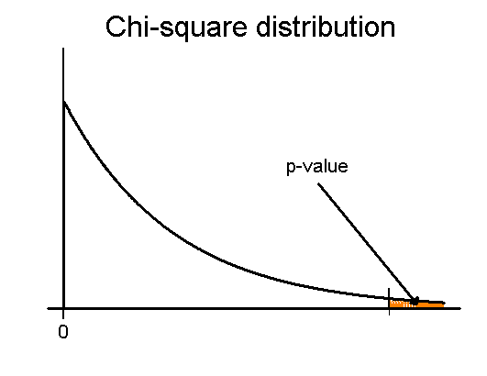

•              The P-value is the probability that a χ2(*R*-1) × (*C*-1) distribution is greater than the observed statistic.

•              Note that all the probability in the p-value (and rejection region) is on one side, since only large values of X2 would contradict H0.

•              Our statistic,  212.3, was larger than 15.20, the 99.95th percentile of a χ22 dist’n, so *p* < 0.0005.

•              Table 6 in the coursepack has χ2 percentiles.

**SPSS output for Chi-square test**





**Notes on Chi-squared test:**

1. Chi-square test p-values rely on Normal approximations, so they not valid for small samples (*any* expected frequencies < 5).
2. The rejection region for a Chi-square test with significance level α is the region above the 100(1- α)th percentile of the Chi-square distribution (i.e. *not* α/2).

3.   The null hypothesis for the Chi-square test can be equivalently formulated as “X1 is independent of X2”, where X1 and X2 are the two categorical variables being compared (gender and perio status in our example).

4.   When comparing two proportions the Chi-square test is equivalent to Z-test.